6th Semester (Major)
2nd Paper (Physical Chemistry)
Macromolecules and Colloids-5

Dr. D. Chakravarty

Molecular weight of Macromolecules:
Macromolecule, any very large molecule, usually with a diameter ranging from about 100 to 10,000 angstroms (10⁻⁵ to 10⁻³ mm). The molecule is the smallest unit of the substance that retains its characteristic properties. The macromolecule is such a unit but is considerably larger than the ordinary molecule, which usually has a diameter of less than 10 angstroms (10⁻⁶ mm). Plastics, resins, many synthetic and natural fibres (e.g., nylon and cotton), rubbers, and the biologically important proteins and nucleic acids are among many substances that are made up of macromolecular units.
Macromolecules are composed of much larger numbers of atoms than ordinary molecules. For example, a molecule of polyethylene, a plastic material, may consist of as many as 2,500 methylene groups, each composed of two hydrogen atoms and one carbon atom. The corresponding molecular weight of such a molecule is on the order of 35,000. Insulin, a protein hormone present in the pancreas and responsible for regulation of blood-sugar levels, has a molecular unit derived from 51 amino acids (by themselves molecules containing carbon, hydrogen, oxygen, nitrogen, and sometimes sulphur). The exact molecular weight of insulin from cattle has been determined to be 5,734.

Number Average and Mass Average Molecular Weight:

The distribution of molecular weights in a polymer sample is often described by the ratio of the weight average molecular weight to the number average molecular weight. In this case the ratio is 531,600/500,000 = 1.063.

The key difference between number average and weight average molecular weight is that the number average molecular weight refers to the mole fraction of molecules in a polymer sample whereas the weight average molecular weight is the weight fraction of molecules in a polymer sample.

The number average molecular weight (M_{N}) is defined as the total weight of polymer divided by the total number of molecules.

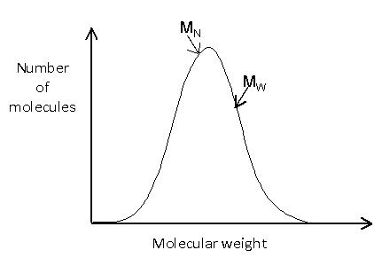

Weight average molecular weight (M_{w}) measuring system includes the mass of individual chains, which contributes to the overall molecular weight of the polymer. It is based on the fact that bigger molecules contain more mass than smaller molecules.

Because of this, polymer molecular weights are usually given as averages. Since larger molecules in a sample weigh more than smaller molecules, the weight average M_{w} is necessarily skewed to higher values, and is always greater than M_{N.}

There are three categories or types of High Molecular Weight (HMW, >10,000 daltons) polymers typically reviewed by the New Chemicals Program: Soluble, Insoluble/non-water absorbing ("non-swellable"), Water absorbing ("swellable").

Determination of molecular weight of Macromolecules

In order to determine the molecular weight and molecular weight distribution of a polymer, one of the most widely applied methods is gel-permeation chromatography. Gel permeation chromatography (GPC) is a term used for when the separation technique size exclusion chromatography (SEC) is applied to polymers.
Molecular Weight of Polymers:
Knowledge of the molecular weight of polymers is very important because the physical properties of macromolecules are affected by their molecular weight. For example, shown in Figure 1 the interrelation between molecular weight and strength for a typical polymer. Dependence of mechanical strength on polymer molecular weight.
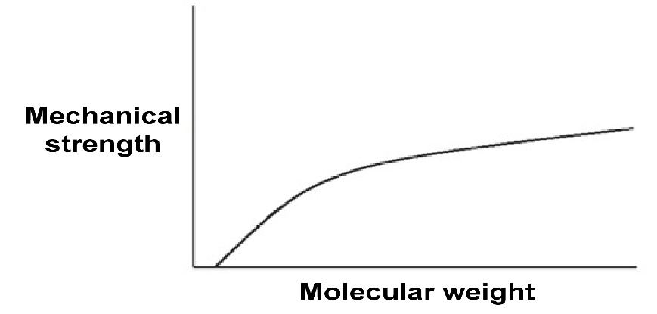
Figure 1: A diagram of the typical curve associating mechanical strength and molecular weight
The melting point of polymers are also slightly depending on their molecular weight. Figure 2 shows relationship between molecular weight and melting temperatures of polyethylene (Figure 3 ) Most linear polyethylene have melting temperatures near 140 °C. The approach to the theoretical asymptote, that is a line whose distance to a given curve tends to zero, indicative that a theoretical polyethylene of infinite molecular weight (i.e., M = ∞) would have a melting point of 145 °C.
The molecular weight-melting temperature relationship for the alkane series.
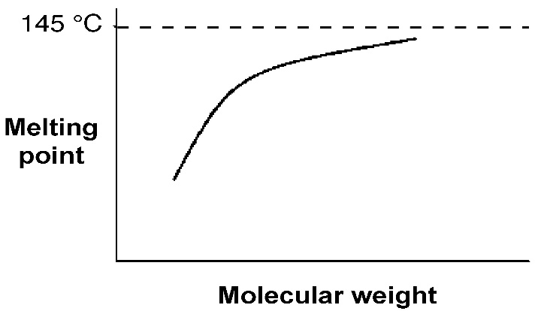
Figure 2: A diagram of the asymptotic approach of the melting point of a polymer to a specific value

.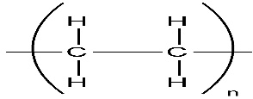

Figure 3: Structure of Polyethylene
There are several ways to calculate molecular weight of polymers like number average of molecular weight, weight average of molecular weight, Z-average molecular weight, viscosity average molecular weight, and distribution of molecular weight.

*******************

