6th Semester (Major)
2nd Paper (Physical Chemistry)
Macromolecules and Colloids-4

Dr. D. Chakravarty
Surface active agents:
A surface active agent, or surfactant, is a substance which lowers the surface tension of the medium in which it is dissolved, the interfacial tension with other phases, and is positively adsorbed at the liquid-vapour interface and other interfaces.
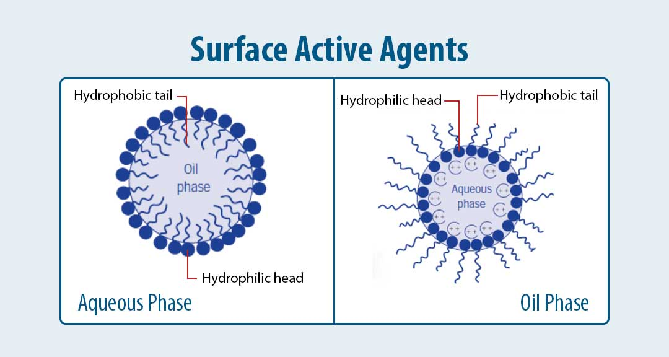
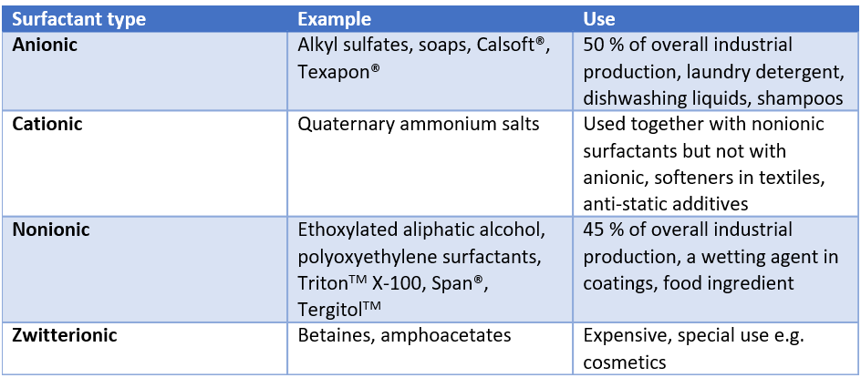

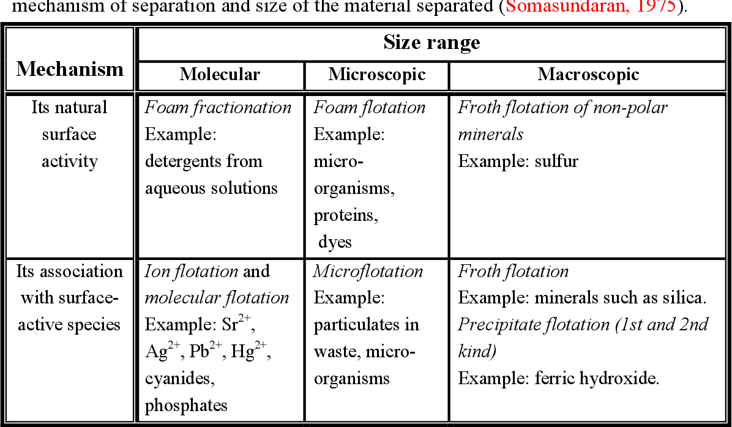

Micelle formation:
Micelles are lipid molecules that arrange themselves in a spherical form in aqueous solutions. The formation of a micelle is a response to the amphipathic nature of fatty acids, meaning that they contain both hydrophilic regions (polar head groups) as well as hydrophobic regions (the long hydrophobic chain).
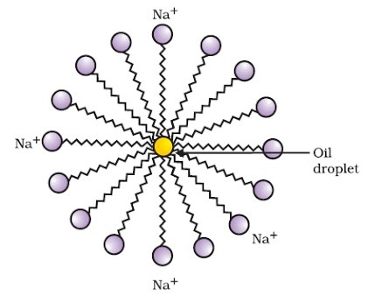

This phase is caused by the packing behavior of single-tail lipids in a bilayer. The difficulty filling all the volume of the interior of a bilayer, while accommodating the area per head group forced on the molecule by the hydration of the lipid head group, leads to the formation of the micelle.

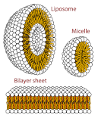

The cleaning action of soap is due to micelle formation and emulsion formation. Inside water a unique orientation forms clusters of molecules in which the hydrophobic tails are in the interior of the cluster and the ionic ends on the surface of cluster. This results in the formation of micelle.
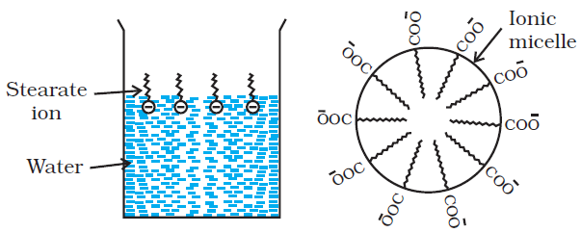

When greasy dirt, fat, or oil is mixed with soapy water, the soap molecules arrange themselves into tiny clusters called micelles. The water-loving (hydrophilic) head of the soap molecules sticks to the water and points outwards, forming the outer surface of the micelle.
For example, soap on dissolving in water, gives sodium and stearate ions. The stearate ions associate to form ionic micelles of colloidal size. Examples of miceller system. The colloidal size aggregates of soap or detergent molecules formed in a concentrated solution are referred to as micelles.
When we wash clothes, the hydrophilic end attaches with the water while the hydrophobic end attaches with the dirt. Thus, a micelle is formed. When we scrub the cloth, the dirt is pulled off as the micelle gets washed away with water taking the dirt with it. Micelles do not dissolve in water but remain as colloids.

******

