Demographic Transition Model
Demographic = to do with population
Transition = Change
Model = in Geography, a model is a simplified way of looking at the world to make it easier to understand.
What is Demographic Transition Model?
Demographic transition (DTM) refers to the transition from high birth and death rates to lower birth and death rates as a country or region develops from a pre-industrial to an industrialized economic system. The demographic transition theory is a generalized description of the changing pattern of mortality, fertility and growth rates as societies move from one demographic regime to another.
The demographic transition model was initially proposed in 1929 by demographer Warren Thompson. Frank Wallace Notestein (August 16, 1902 – February 19, 1983) was an American demographer who contributed significantly to the development of the science. He was the founding director of the Office of Population Research at Princeton University, and later president of the Population Council. The demographic transition model is now over half a century old. It is the product of observations regarding population growth and development across numerous countries throughout the world.
The demographic transition model operates on the assumption that there is a strong association between birth and death rates, on the one hand, and industrialization and economic development on the other. This is a safe assumption in most cases as it has been demonstrated to be consistently true by many historical instances of industrialization and development since the 19th century.

Demographic Transition Model Stages
The demographic transition model consists of four key stages. There is also a fifth stage that is a bit less established; we will explain why that is the case. Finally, the sixth stage is a much newer development in this field and demonstrates the degree to which the demographic transition model remains evolving and in flux.
Stage 1: STAGE OF LOW GROWTH RATE
Pre-Industrial which applied to most of the world before the Industrial Revolution, both birth rates and death rates are high. As a result, population size remains fairly constant but can have major swings with events such as wars or pandemics. Population growth is typically very slow in this stage, because the society is constrained by the available food supply living conditions, food output, environmental conditions, any fluctuations in birth rates are soon matched by death rates and prevented population growth from occurring on a global scale.
Stage 2: HIGH GROWTH RATE/ POPULATION EXPOLSION
Around the mid-1700s, global populations began to grow ten times faster than in the past for two reasons: The Industrial Revolution and increased wealth. The Industrial Revolution brought with it a variety of technological improvements in agricultural production and food supply. Increased wealth in Europe, and later North America, because of the Industrial Revolution, meant that more money and resources could be devoted to medicine, medical technology, water sanitation, and personal hygiene. Sewer systems installed in cities led to public health improvements. All of this dramatically caused CDRs to drop around the world. At first, CBRs stayed high as CDRs decreased; this caused populations to increase in Europe and North America. Over time, this would change. The improvements specific to food supply typically include selective breeding and crop rotation and farming techniques. Other improvements generally include access to technology, basic healthcare, and education. For example, numerous improvements in public health reduce mortality, especially childhood mortality. Prior to the mid-20th century, these improvements in public health were primarily in the areas of food handling, water supply, sewage, and personal hygiene. Another variable often cited is the increase in female literacy combined with public health education programs which emerged in the late 19th and early 20th centuries. This is the point at which the country begins to experience social and economic development. With more productive agriculture (and thus more food supply), better medical care, and more effective sanitation and hygiene, death rates fall quickly and lifespan are longer. The birth rate, however, does not fall at the same time (it does not increase, but rather remains high). Birth rates far outpace death rates with the result that the population grows rapidly.
Developing country the introduction of modern medicine lowers death rates, especially among children, while birth rates remain high; the result is rapid population growth. Many of the least developed countries today are in Stage 2
- Medical care will be improved (vaccinations, scientific improvements, doctors and new drugs);
- Sanitation and water supplies will be much better;
- The quality and security of food will be improved;
- There will be a noticeable decrease in child mortality.

Stage 3: LATE TRANSITION / POPULATION GROWTH STARTS TO LEVEL OFF
In stage three, birth rates fall. Mexico’s population is at this stage. Birth rates decrease due to various fertility factors such as access to contraception, increases in wages, urbanization, a reduction in subsistence agriculture, an increase in the status and education of women, a reduction in the value of children’s work, an increase in parental investment in the education of children and other social changes. Population growth begins to level off. The birth rate decline in developed countries started in the late 19th century in northern Europe. While improvements in contraception do play a role in birth rate decline, it should be noted that contraceptives were not generally available nor widely used in the 19th century and as a result likely did not play a significant role in the decline then.
It is important to note that birth rate decline is caused also by a transition in values; not just because of the availability of contraceptives. Birth rates gradually decrease, usually as a result of improved economic conditions, an increase in women’s status, and access to contraception. Population growth continues, but at a lower rate. Most developing countries are in Stage 3
- Increased use of family planning methods;
- Much lower infant mortality rates will mean that more children will survive and there is less need to have as many babies;
- Increased opportunity for employment in factories means that fewer people (and children) are required to work on the land;
- Changes to society put more desire on material possessions than large families;
- Changes to equality mean that women are increasingly in the workforce and not ‘staying at home’ to look after the children.
Today, Europe and North America have moved to Stage 3 of the demographic transition model. A nation moves from Stage 2 to Stage 3 when CBRs begin to drop while CDRs simultaneously remain low or even continue to fall. It should be noted that the natural rate of increase in nations within Stage 3 is moderate because CBRs are somewhat higher than CDRs. The United States, Canada, and countries in Europe entered this stage in the early 20th Century. Latin American nations entered this stage later in the century.
Advances in technology and medicine cause a decrease in IMR and overall CDR during Stage 2. Social and economic changes bring about a reduction in CBR during Stage 3. Nations that begin to acquire wealth tend to have fewer children as they move away from rural-based development structures toward urban-based structures because more children survive, and the need for large families for agricultural work decreases. Additionally, women gain more legal rights and chose to enter the workforce, own property, and have fewer children as nations move into Stage 3.

Stage 4: STATIONARY POPULATION
Post-transition Birth and death rates are both low, stabilizing the population. These countries tend to have stronger economies, higher levels of education, better healthcare, a higher proportion of working women, and a fertility rate hovering around two chi drop per woman. Most developed countries are in Stage 4. During stage four there are both low birth rates and low death rates. Birth rates may drop to well below replacement level as has happened in countries like Germany, Italy, and Japan, leading to a shrinking population, a threat to many industries that rely on population growth. Sweden is considered to currently be in Stage 4. As the large group born during stage two ages, it creates an economic burden on the shrinking working population. Death rates may remain consistently low or increase slightly due to increases in lifestyle diseases due to low exercise levels and high obesity and an aging population in developed countries. By the late 20th century, birth rates and death rates in developed countries leveled off at lower rates.
{A nation enters Stage 4 of the demographic transition model when CBRs equal to or become less than CDRs. When CBRs are equal to CDRs, a nation will experience zero population growth (ZPG). It should be noted that sometimes a nation could have a slightly higher CBR, but still experience ZPG. This occurs in many countries where girls do not live as long before they reach their childbearing years due to gender inequality.
When a country enters Stage 4, the population ages, meanwhile fewer children are born. This creates an enormous strain on the social safety net programs of a country as is tries to support older citizens who are no longer working and contributing to the economy. Most of Europe has entered Stage 4. The United States would be approaching this stage if it were not for migration into the country.
A nation in the first two stages of the transition model will have a broad base of young people and a smaller proportion of older people. A country in Stage 4 will have a much smaller base of young people (fewer children), but a much larger population of elderly (decreased CDR). A nation with a large youth population is more likely to be rural with high birthrates and possibly high death rates. This can tell geographers a lot about the health care system of that nation. Moreover, a country in Stage 4 with a large elderly population will have much fewer young people supporting the economy. These two examples represent the dependency ratio, mentioned earlier in this chapter. This ratio is the number of people, young and old, who are dependent on the working force.
Human geographers like to focus on the following demographic groups: 0-14 years old, 15-64 years old, and 65 and older. Individuals who are 0-14 and over 65 are considered dependents (though this is changing in older generations). One-third of all young people live in emerging nations, and this places considerable strain on those nations’ infrastructure such as schools, hospitals, and day-care. Older individuals in more developed nations (MDL) benefit from health care services, but require more help and resources from the government and economy. The author of this textbook uses the term “emerging nations,” rather than “less developed” or “developing,” or “third-world” nations as a more inclusive and equitable term.
Another ratio geographers look at is the number of males compared to females. This is called the sex ratio. Globally, more males are born than females, but males also have a higher death rate than females. However, understanding a nation’s sex ratio and its dependency ratio helps human geographers analyze fertility rates and natural increase.
As noted earlier, population growth has increased dramatically in the last century. No country is still in Stage 1, and very few have moved into Stage 4. The majority of the world is either in Stage 2 or 3, both having higher crude birth rates than crude death rates; therefore, the world’s population is over 7 billion today.
In summary, the demographic transition model is a model that helps human geographers understand and predict the demographics of individual nations. In Stage 1, CBR and CDR are very high and thus produce a low natural increase. In Stage 2, a nation’s CBR stays relatively high, but the CDR drops dramatically, producing the highest growth in population. In Stage 3, CDR stays low; however, changes in social customs and economic conditions result in a moderately low CBR. Finally, nations in Stage 4 have nearly equal CBR and CDR (sometimes higher CDR), creating a drop in natural increase}.

Stage 5: Further Changes in Birth Rates
Debated would include countries in which fertility rates have fallen significantly below replacement level (2 children) and the elderly population is greater than the youthful population. This stage is a bit more uncertain. At this stage, some demographers say that fertility rates will experience shifts to either above or below replacement levels. While some experts argue that fertility levels will increase, others state the opposite. This depends on the society, too: while populations in China and Australia are expected to fall due to lower birth rates, those in the U.S., India, and Mexico are expected to increase. Additional stages have also been proposed—this is a contested area and theorists have quite a bit more work to do to come to some kind of consensus within the field of demography.

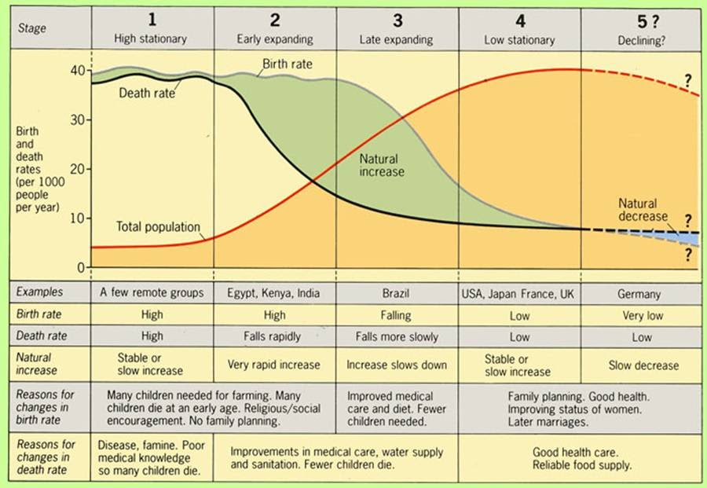

Conclusions
As with all models, this is an idealized picture of population change in these countries. The model is a generalization that applies to these countries as a group and may not accurately describe all individual cases. The extent to which it applies to less-developed societies today remains to be seen. Many countries such as China, Brazil and Thailand have passed through the Demographic Transition Model (DTM) very quickly due to fast social and economic change. Some countries, particularly African countries, appear to be stalled in the second stage due to stagnant development and the effect of AIDS.

Summarizing the Stages
The descriptions above are quite detailed, so here is a more succinct summary of the five stages:
- Stage 1: This is a state of high birth and death rates culminating in low population growth overall.
- Stage 2: With a consistently high birth rate and decreasing death rate, population growth surges.
- Stage 3: As the birth rate falls and the death rate remains low, the population continues to increase.
- Stage 4: Traditionally considered to be the final stage, this is one of demographic stabilization, in which both birth and death rates are low. This means that the overall population stays fairly low.
- Stage 5: This final, contested stage may predict higher or lower fertility levels depending on which theorist you ask.

Limitations:-
1. Limited Predictive Capacity
The demographic transition model is a highly useful model for making educated guesses about how populations are likely to shift in the future. Rooted as it is in a wide array of real-world population trends, it is considered to be an empirical model, as it is based on actual data and observation. However, it is just that: a model. It is not an absolute equation—it cannot reliably predict what will actually happen, and certainly cannot do so in great detail. Each country has its own set of social and cultural attributes that can heavily influence its demographics, causing them to operate differently than you might expect based solely on the DTM.
One prominent example of this unpredictability is that of Russia. You might guess that their continuing economic development would mean the country’s population would follow the patterns of the DTM. However, nearly 25 percent of men in Russia do not live past roughly age 55. This devastating reality is rooted in a number of complex and interconnected social, cultural, and economic factors. The situation is simply more complicated than the DTM could possibly predict.
Furthermore, economic development does not guarantee the kind of social changes that would lead to a reduction in birth rates. For instance, a country might experience significant economic development and industrialization without providing women with widespread access to birth control. Without birth control, birth rates would remain high. For this reason they would not be likely to make it to stage 3, at which point birth rates begin to fall.
2. The DTM Itself is continuing to Shift
As described above, when first established, the demographic transition model had just four stages. Demographers then added a fifth stage to accommodate new trends in development they had noticed. This contested status demonstrates that the model is not set in stone enough to be considered absolutely foolproof. Experts note that the DTM is likely to continue to evolve as the real world evolves.
3. Significant Influence of Migration
Migration is also a significant factor in demographic shifts, and one for which the demographic transition model does not explicitly account. Both in- and out-migration affect natural and actual increases and decreases in population. The effect of migration depends especially on migrants’ fertility, social attitudes, age, gender, and other identity factors.
4. The DTM was created are studying the development of countries in western Europe and Northern America, and therefore many argue that it cannot necessarily be transferred across for the use in LEDCs as many conditions might be different.
5. The original model does not take into account the fact that some countries actually now have a declining population, and therefore the original DTM did not have a 5th stage. However, this stage is now shown as it relates to an increasing number of MEDCs in the 21st century.

