Chemical Thermodynamics 03

Dr. D. Chakravarty.
- Calculations of –
- q, w, U & H for reversible process
- q, w, U & H for irreversible process
- Free expansion of ideal gas & van der Walls gases under isothermal conditions
- Free expansion of ideal gas & van der Walls gases under adiabatic conditions
- Law of equipartition of energy
- Degrees of freedom & molecular basis of heat capacities.

Basic Definition:

- Process: A process is a path along which a change of state is take place. The process can occur under a variety of conditions and many things may depend on the nature of the process. They are-
- Isothermal Process: The process is occurs under constant Temperature condition.
- Isobaric Process: The process is occurs under constant Pressure condition.
- Isochoric Process: The process is occurs under constant Volume condition.
- Adiabatic Process: The process is occurs under such a condition that the Heat is unaltered during the process in the system.
- Cyclic Process: The process is occurs in such a way that the system undergoes a series of changes and ultimately come back (reached) to its initial state.
- Reversible Process: A reversible process is a process whose direction of transformation can be returned to its original position by inducing several infinitesimal changes to some property of the system via its surroundings. Throughout the entire reversible process, the system is in thermodynamic equilibrium with its surroundings.
- Irreversible Process: An irreversible process is a process whose direction of transformation cannot be returned to its original position by inducing several infinitesimal changes to some property of the system without expenditure of energy. All natural processes are irreversible process.

1.. Work done in Reversible Process:
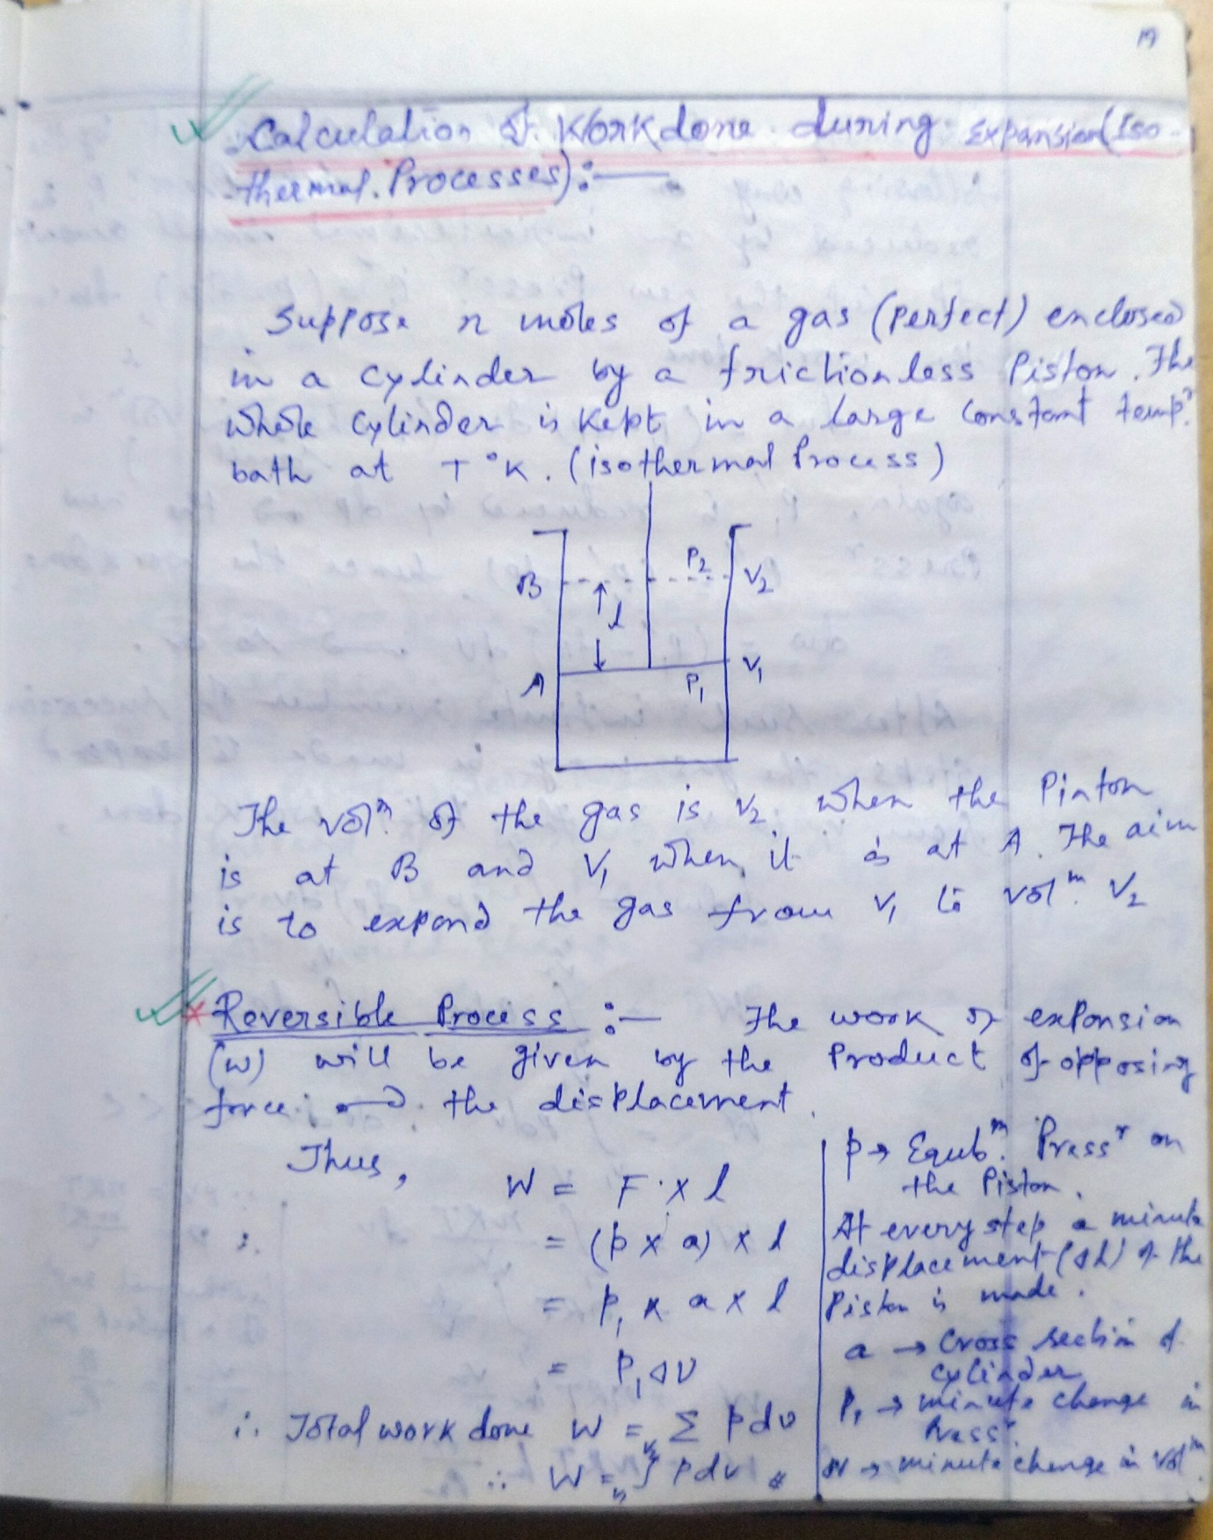
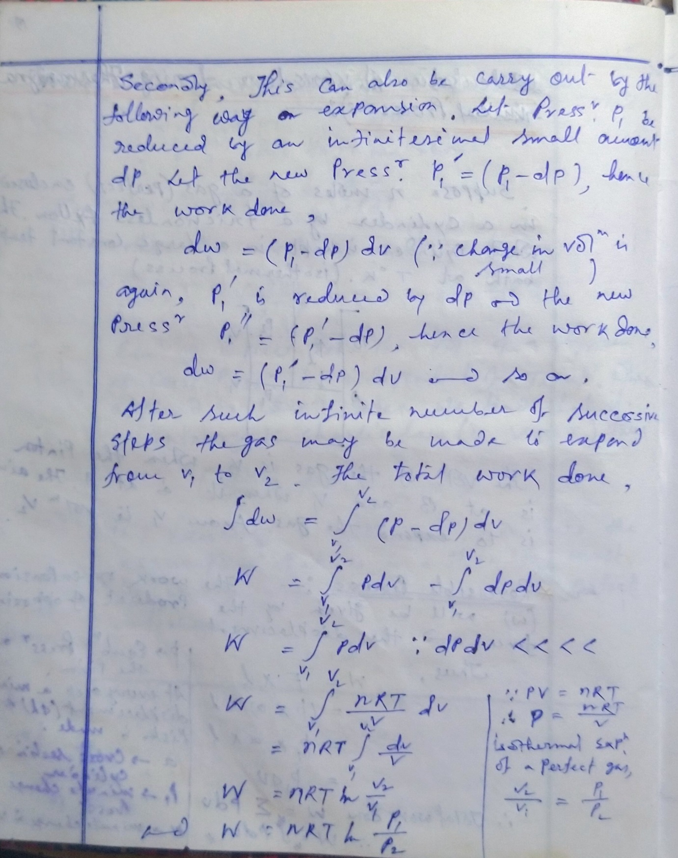

- Work done in Irreversible Process:

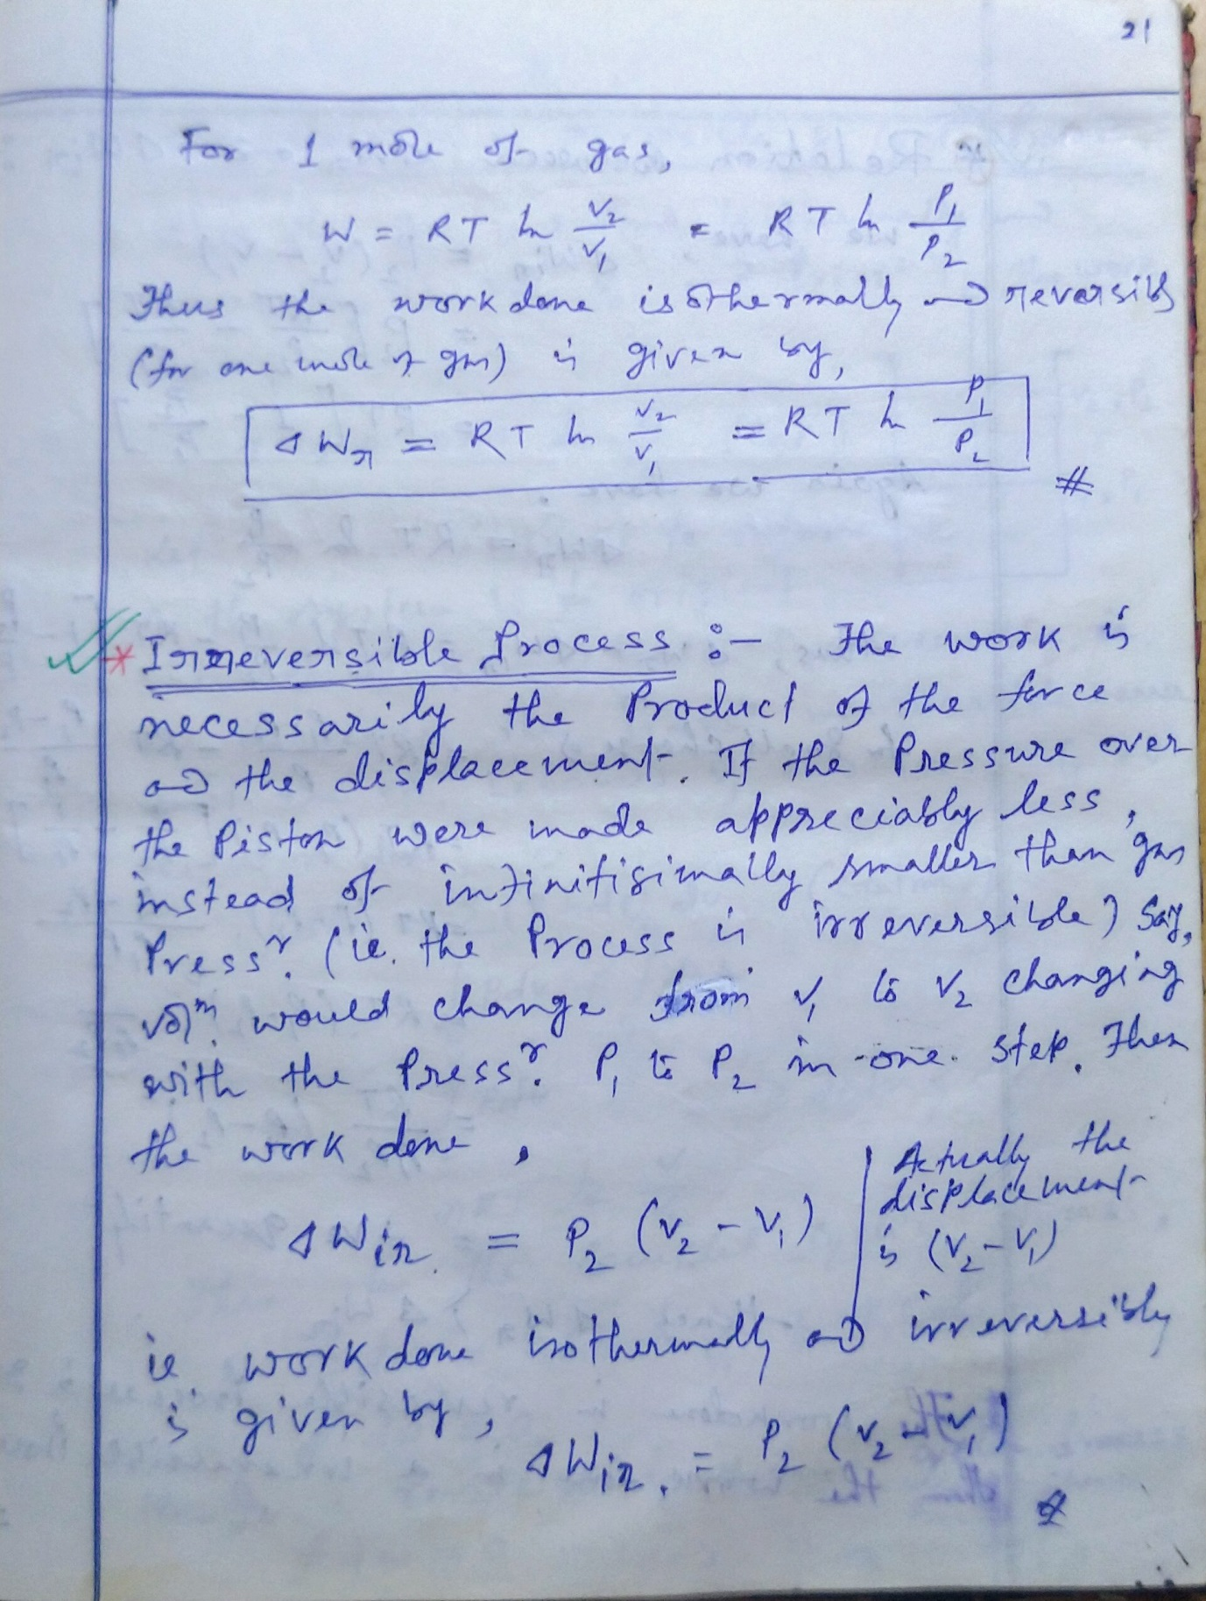

- Relation between Reversible Work done & Irreversible Work done:
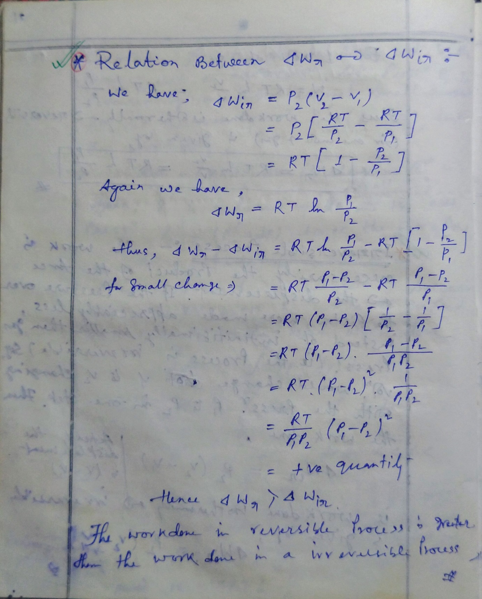

- Work done in a Reversible & Cyclic Process:



