Unit: 6.1

Introduction to Spectroscopy

Dr. D. Chakravarty.

1.4. Absorption & Emission Spectroscopy:

Absorption lines are usually seen as dark lines, or lines of reduced intensity, on a continuous spectrum. This is seen in the spectra of stars, where gas (mostly hydrogen) in the outer layers of the star absorbs some of the light from the underlying thermal blackbody spectrum.

The principle of flame photometer is based on the measurement of the emitted light intensity when a metal is introduced into the flame. The wavelength of the colour gives information about the element and the colour of the flame gives information about the amount of the element present in the sample.

The difference between absorption and emission spectra are that absorption lines are where light has been absorbed by the atom thus it looks a dip in the spectrum whereas emission spectra have spikes in the spectra due to atoms releasing photons at those wavelengths.

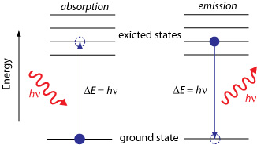

Emission spectra:
It is learnt from the structure of an atom the electrons surrounding the atomic nucleus are arranged in a series of levels of increasing energy. Each element has a unique number of electrons in a unique configuration therefore each element has its own distinct set of energy levels. This arrangement of energy levels serves as the atom's unique fingerprint.
In the early 1900s, scientists found that a liquid or solid heated to high temperatures would give off a broad range of colours of light. However, a gas heated to similar temperatures would emit light only at certain specific wavelengths (colours). The reason for this observation was not understood at the time. Scientists studied this effect using a discharge tube as given in the Figure 01.
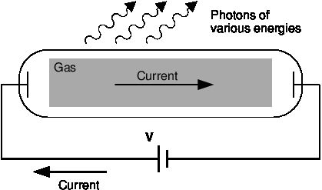

Figure 01: Diagram of a discharge tube. The tube is filled with a gas. When a high enough voltage is applied across the tube, the gas ionises and acts like a conductor, allowing a current to flow through the circuit. The current excites the atoms of the ionised gas. When the atoms fall back to their ground state, they emit photons to carry off the excess energy.
A discharge tube is a gas-filled, glass tube with a metal plate at both ends. If a large enough voltage difference is applied between the two metal plates, the gas atoms inside the tube will absorb enough energy to make some of their electrons come off, i.e. the gas atoms are ionised. These electrons start moving through the gas and create a current, which raises some electrons in other atoms to higher energy levels. Then as the electrons in the atoms fall back down, they emit electromagnetic radiation (light). The amount of light emitted at different wavelengths, called the Emission Spectrum, is shown for a discharge tube filled with hydrogen gas shown in Figure 02.
Figure 02: Diagram of the emission spectrum of hydrogen in the visible spectrum. Four lines are visible, and are labelled with their wavelengths. The three lines in the 400 nm – 500 nm range are in the blue part of the spectrum, while the higher line (656 nm) is in the red / orange part.

Eventually, scientists realised that these lines come from photons of a specific energy, emitted by electrons making transitions between specific energy levels of the atom. Figure 03a & Figure 03b shows an example of this happening. When an electron in an atom falls from a higher energy level to a lower energy level, it emits a photon to carry off the extra energy. This photon's energy is equal to the energy difference between the two energy levels (ΔE).

ΔE_{electron} = E_{f} –E_{i}
As we previously discussed, the frequency of a photon is related to its energy through the equation E = hf. Since a specific photon frequency (or wavelength) gives us a specific colour, we can see how each coloured line is associated with a specific transition.

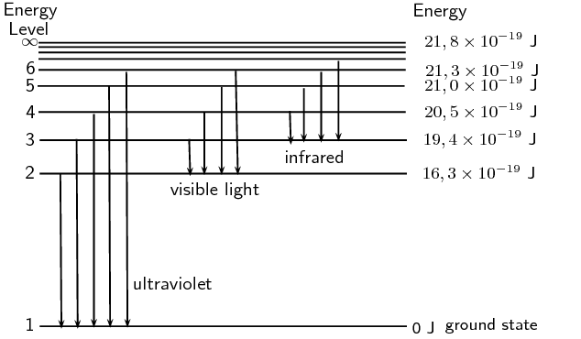
Figure 03a: Figure shown some of the electron energy levels for the hydrogen atom. The arrows show the electron transitions from higher energy levels to lower energy levels. The energies of the emitted photons are the same as the energy difference between two energy levels. You can think of absorption as the opposite process. The arrows would point upwards and the electrons would jump up to higher levels when they absorb a photon of the right energy.

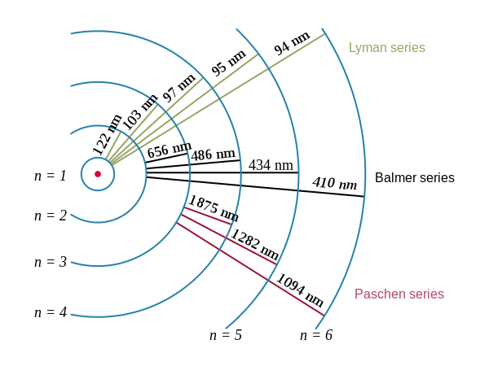

Figure 03b: Figure shows the wavelengths of the light that is emitted for the various transitions. The transitions are grouped into a series based on the lowest level involved in the transition.

Visible light is not the only kind of electromagnetic radiation emitted. More energetic or less energetic transitions can produce ultraviolet or infrared radiation. However, because each atom has its own distinct set of energy levels (its fingerprint), each atom has its own distinct emission spectrum.

Absorption spectra:
Atoms do not only emit photons; they also absorb photons. If a photon hits an atom and the energy of the photon is the same as the gap between two electron energy levels in the atom, then the electron in the lower energy level can absorb the photon and jump up to the higher energy level. If the photon energy does not correspond to the difference between two energy levels then the photon will not be absorbed (it can still be scattered).
Using this effect, if we have a source of photons of various energies we can obtain the absorption spectra for different materials. To get an absorption spectrum, just shine white light on a sample of the material. White light is made up of all the different wavelengths of visible light put together. In the absorption spectrum there will be gaps correspond to energies (wavelengths) for which there is a corresponding difference in energy levels for the particular element.
The absorbed photons show up as black lines because the photons of these wavelengths have been absorbed and do not show up. Because of this, the absorption spectrum is the exact inverse of the emission spectrum.
Emission spectrum of Hydrogen.
Absorption spectrum of Hydrogen.
Look at the two figures below. In Figure 12.8 you can see the line emission spectrum of hydrogen. Figure 12.9 shows the absorption spectrum. It is the exact opposite of the emission spectrum. Both emission and absorption techniques can be used to get the same information about the energy levels of an atom.

The dark lines correspond to the frequencies of light that have been absorbed by the gas. As the photons of light are absorbed by electrons, the electrons move into higher energy levels. This is the opposite process of emission.
The dark lines, absorption lines, correspond to the frequencies of the emission spectrum of the same element. The amount of energy absorbed by the electron to move into a higher level is the same as the amount of energy released when returning to the original energy level.

**************

