Conductance 01
Dr. D. Chakravarty
- Arrhenius theory of electrolytic dissociation-
- Conductivity, Equivalent Conductivity & Molar Conductivity-

- Arrhenius theory of electrolytic dissociation-
Svante Arrhenius was a Swedish scientist born in 1859. He got the noble prize in chemistry for his theories on ions, that led to his theories and definitions of acids and bases.
Arrhenius noticed that acid solutions were good conductors of electricity; they were electrolytes. To be able to conduct electricity a substance must have ions that can freely move around. From this, Arrhenius drew the conclusion that acidic substances when dissolved broke down into ions, and that all acidic substances produced hydrogen ions in this process.
Arrhenius stated the theory – that acid produced hydrogen anions (H⁺) and bases produced negative hydroxide ions (OH⁻) when dissolved in water. This explained neutralisation the following way:
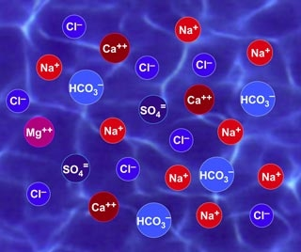
Fig: Ions formed by substances dissolved in water –
an important part of Arrhenius' theory
Lets say the base XOH and the acid YH, are both dissolved in water. According to Arrhenius theory, the following reaction takes place:
First, both substances break down to ions: XOH à X⁺ + OH⁻ and YH à Y⁻ + H⁺
Then, the substances react to form a salt and water: XOH + YH → X⁺+Y⁻+OH⁻+H⁺ à XY + H₂O

Limitations of Arrhenius’ theory:
Arrhenius’ theory was important for a number of reasons –
It was first theory to produce comprehensive criteria for acids and bases, It was also the first theory on acids and bases that recognised the importance of solvents in neutralisation and the production of water during the reaction.
Whereas there is a big gap in Arrhenius’ theory that, it can’t explain why ammonia is a base, and why water can act as a base or an acid in certain reactions. Also, the theory can't be applied to acid-base reactions in solvents other than water or in no solvent at all.

- Conductivity, Equivalent Conductivity & Molar Conductivity-
The electrical conductivity of a solution of an electrolyte is measured by determining the resistance of the solution between two flat or cylindrical electrodes separated by a fixed distance
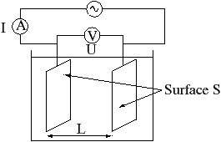
Fig. Principle of Measurement
Resistance, R, is proportional to the distance, l, between the electrodes and is inversely proportional to the cross-sectional area of the sample, A (noted S on the Figure above). Writing ρ (rho) for the specific resistance (or resistivity),
R = l / A . ρ
In practice the conductivity cell is calibrated by using solutions of known specific resistance, ρ*, so the quantities l and A need not be known precisely.^{[10]} If the resistance of the calibration solution is R*, a cell-constant, C, is derived.
R* = C X ρ*
The specific conductance (conductivity), κ (kappa) is the reciprocal of the specific resistance.
κ = 1 / ρ = C / R
Conductivity is also temperature-dependent. Sometimes the ratio of l and A is called as the cell constant, denoted as G*, and conductance is denoted as G. Then the specific conductance κ (kappa), can be more conveniently written as

Κ = G* X G

*********

